Dana Monzer – IEMS 469 – Nov 5, 2023
Homework #2 – Problem #2

Algorithm
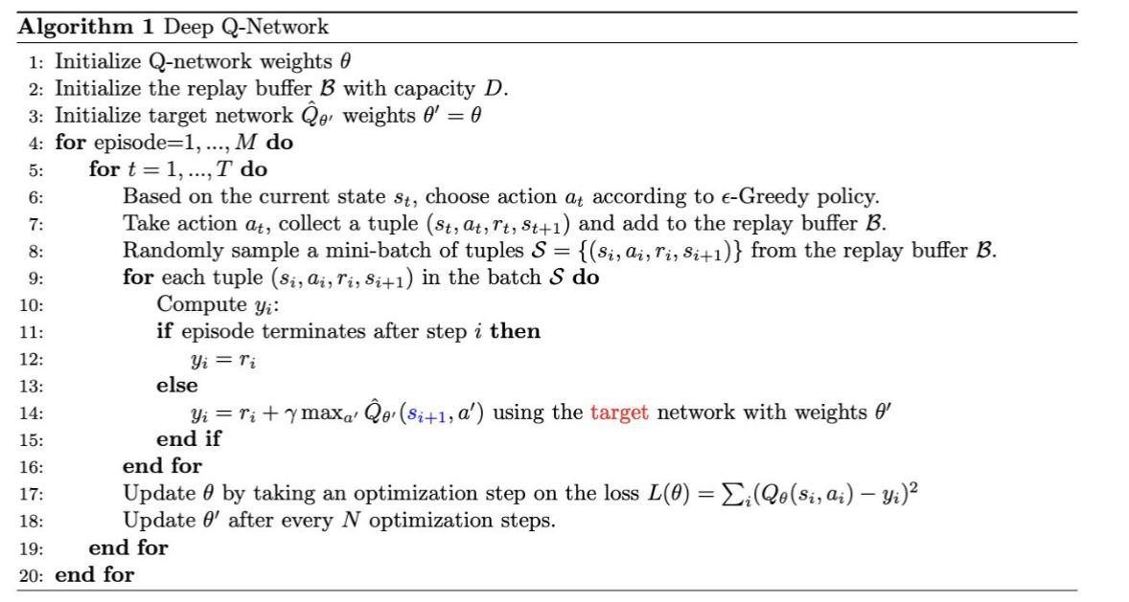

Best Run Results
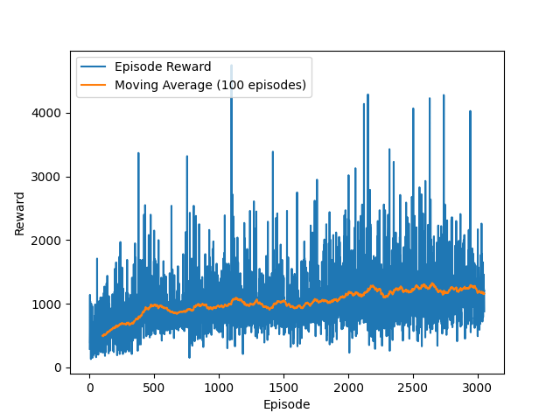
Figure 1: Episode Rewards plot for final run
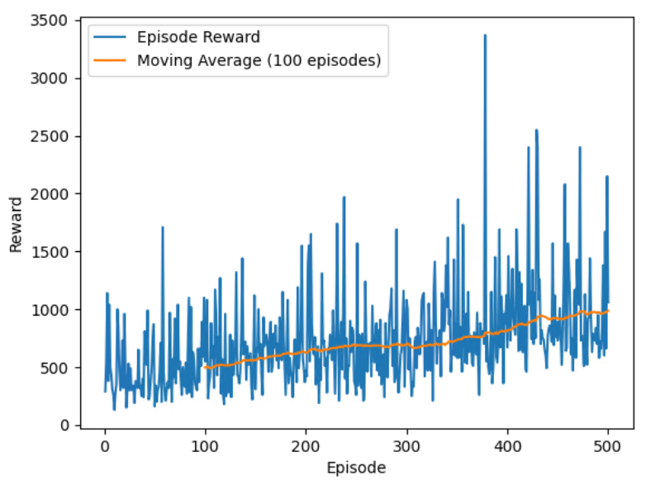

Figure 2: Average Qmax plot during training episodes for final run
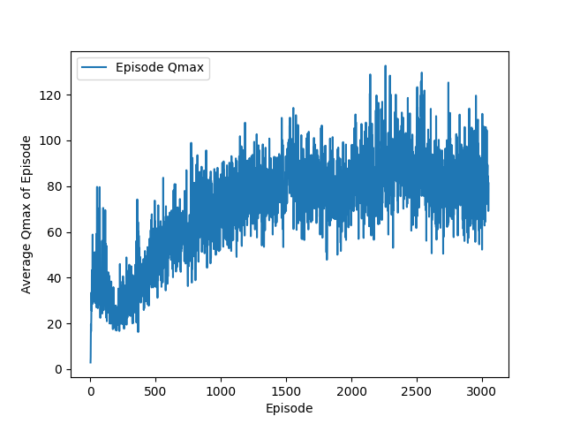
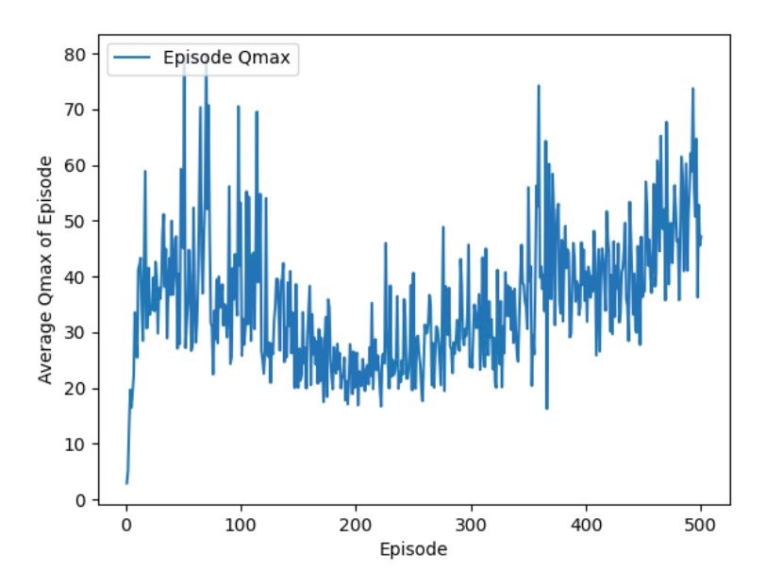
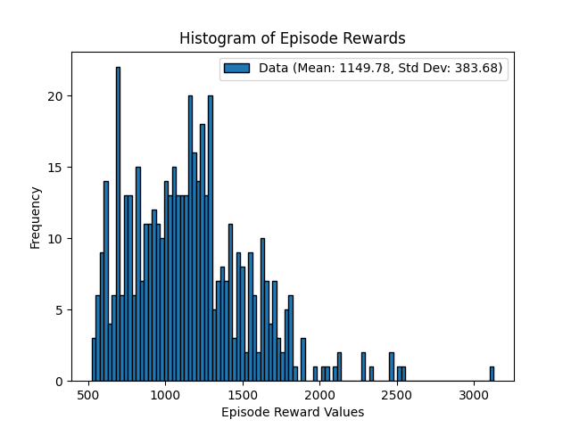

Figure 4:Histogram of Episode Rewards of a sample of 500 episodes using trained model

References
- https://www.youtube.com/watch?v=EjYEsbg95x0
- PyTorch Tutorial for DQN
- https://www.nature.com/articles/nature14236

